[ FODDIE ]

**Project Progress Report**



**Department of Electrical and Computer Engineering North South University CSE 299: Junior Project Design**

**Group Member:**

**1. Md. Ahasun Kamal (1530187042) 2. Sifat Anwar(1812887642)**

**TABLE OF CONTENT**

1. **PROGRESS & ACHIEVEMENTS**
2. **OBSTACLES**
3. **MILESTONES & REPORTING**

**1.PROGRESS & ACHIEVEMENTS**

At this stage of our project, we have successfully added multiple functionalities to our fooide web-app like we outlined in our Project Proposal. We have created functionalities to make and add some restaurant for customers and also add food itam for them.both member work together.here are those funtionality.user can click his chosen restaurant.then he can go the

My cart of the restaurant and order food he chose.

1. sifat anwar worked on the search box and add restaurent here.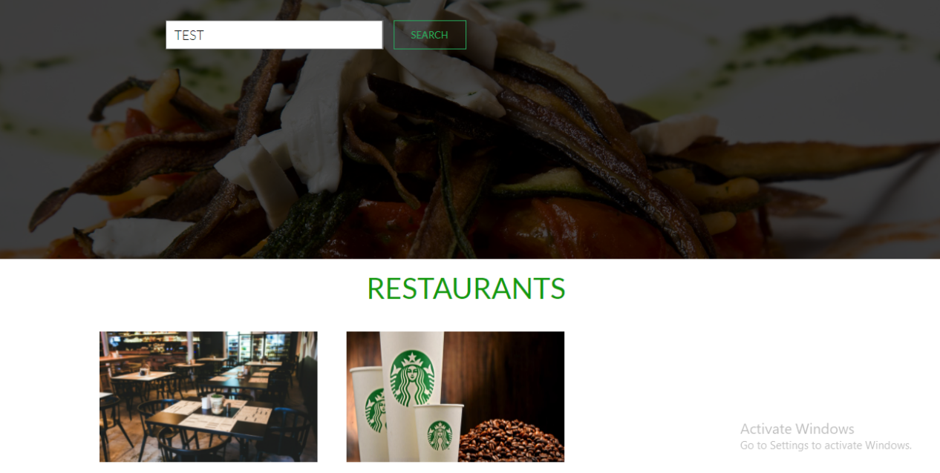

Here are restaurent we addaed yet we want more restaurent.

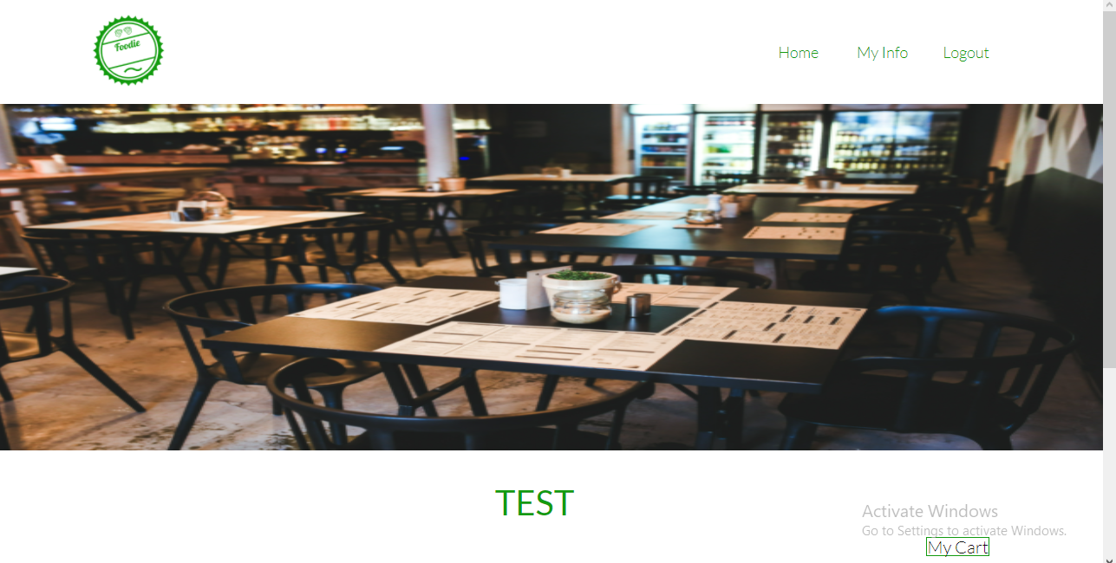

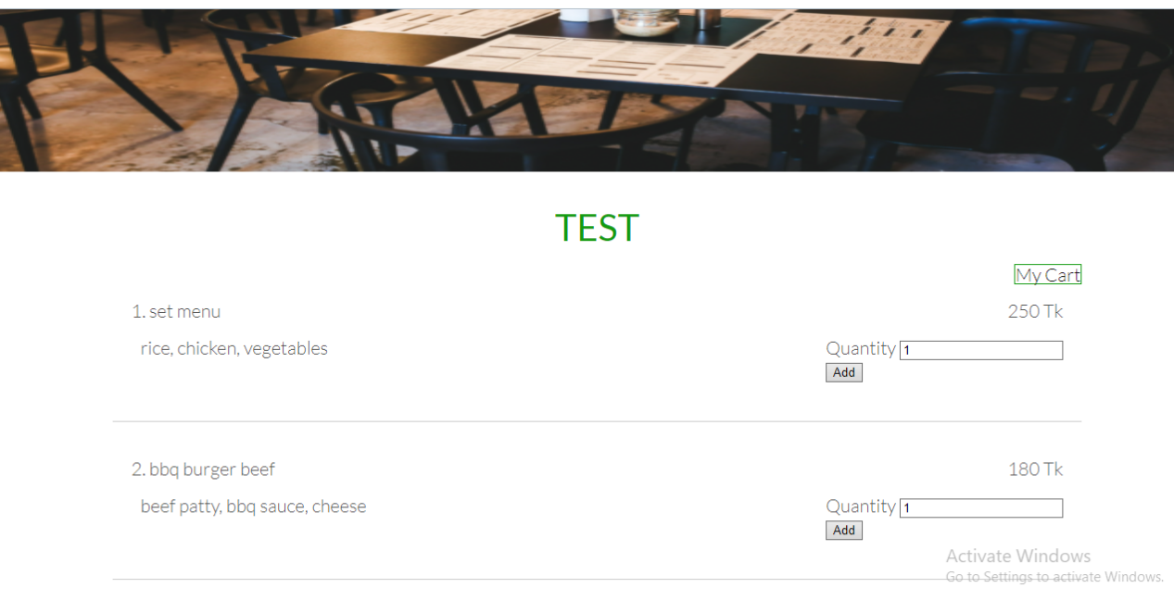

1. group respresntetor ahasanul kamal also worked on this add restaaurent.he

worked connection database to user interface.he worked on add functinality.

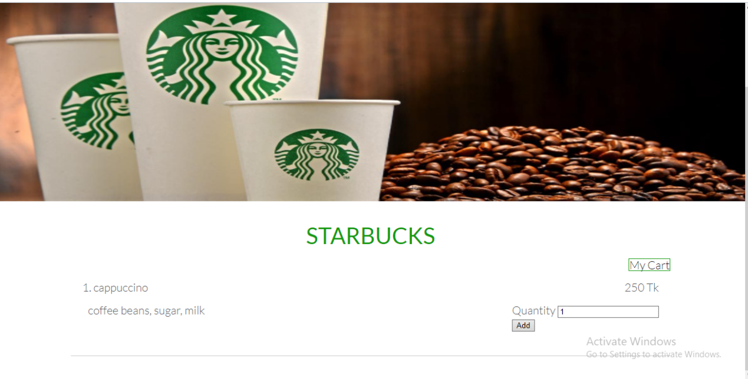

**2.OBSTACLES**

The primary obstacle that the team faced was regarding task dependencies. In our original Project Proposal, the order that we maintained while writing the Project Breakdown had a few task dependency issues where we did not oversee how the completion of one feature would half the progress of another feature.threre we fined some error we fixed it.

## **3.MILESTONES & REPORTING**

According to our original Project Proposal, we are in the final stages of implementation of our project. We hope to complete stage 1 in the next couple of weeks. Immediately after today, we will be working on adding more features, as previously mentioned.

A slight modification of our original project breakdown is included below. We have just shuffled a few tasks on the basis of dependency.

|  |  |  |
| --- | --- | --- |
| **Milestone** | **Tasks** | **Date** |
| Week-1 | Project idea and proposal | 03-07-2021 |
| Week-2 | New language learning and codinng standerd | 11-07-2021 |
| Week-3 | Design work plan | 18-07-2021 |
| Week-4 | Create database | 25-07-2021 |
| Week-5 | User case daigram | 07-08-2021 |
| Week-6 | Add factionality | 15-08-2021 |
| Week-7 | Create GUI | 20-08-2021 |
| Week-8 | Database connection | 27-08-2021 |
| Week-9 | Progress Report Due | 05-09-2021 |
| Week-10 | Final presention | 12-09-2021 |
| Week-11 | Final report(thesis) | 15-09-2021 |